Project 1 Report

Rachel Weber

October 7, 2018

## Background

This report addresses the dearth of information about how hard drug use impacts treatment response in HIV positive patients. The data used are comprised of gay and bisexual men enrolled in an ongoing cohort study on treatment of HIV/AIDS with HAART therapy. All men are introduced at baseline prior to starting treatment and are followed for up to 8 years with biological measures of health and mental/physical quality of life (QOL) assessments. Other demographic variables were collected including education, income, drug/alcohol habits, smoking status, and education level. Additionally, patient adherence to the HAART treatment was recording after baseline to know how well patients were sticking to medication protocol.

The researchers are specifically assessing the difference in 4 measures (Viral Load, T-Cell Count, Mental QOL, and Physical QOL) of health at 2 years between men who reported hard drugs use and those who didn’t. There were 715 total patients enrolled at baseline. All patients were first filtered to remove those who did not report demographic information at their baseline clinic visit or who were lost to follow-up by year two. Additionally, patients with unrealistic BMI values had those measures removed. The models were then run based on either complete lab results (for Viral Load and T-Cell count) or on complete health assessment results (for mental and physical health). All 474 patients who remained after data cleaning had viral load and T-Cell counts measured at year two. 468 had scores for mental and physical health. Below is a descriptive table for the full 474 people in the analysis set.

Table 1: Baseline Demographic Information

|  |  |
| --- | --- |
|  | N = 474 |
|  | *N(%)* |
| Race |  |
| Non-White | 152(32) |
| White | 322(68) |
| Smoke |  |
| Non-smoker | 294(62) |
| Smoker | 180(38) |
| Hard Drugs |  |
| No | 438(92) |
| Yes | 36(8) |
| Education |  |
| < College | 269(57) |
| > College | 104(22) |
| 4 years/Degree | 101(21) |
|  | *Mean(SD)* |
| BMI | 25.24(4.363) |
|  | *Median(IQR)* |
| Age | 43(37-48) |

Figure 1 shows the trends in each outcome measure between baseline (year 0) and year 2. Viral load and T-Cell count trend quite similarly between groups and both show marked improvement by year 2. Mental health increases for both groups by year two but does have a less consistent trend. Physical health seemed to trend downward for patients reporting hard drugs use and upward for patients who did not.

*Figure 1: Trends for each outcome over time*

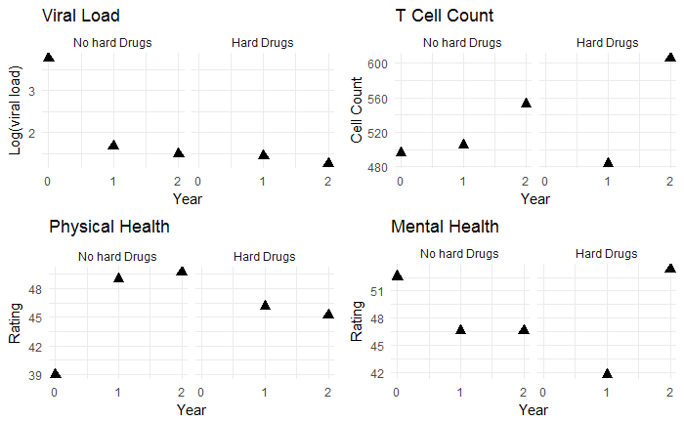

### Methods

To prepare for model building, some variables were restructured to better meet analysis needs. Such restructuring included the condensing of education into ‘less than college level’, ‘college degree’, and ‘more than college’. In addition, Smoking was condensed to ‘non-smokers’ (which included former smokers) and ‘current smokers’ and Race was converted to ‘White’ and ‘Non-white’ due to lack of diversity in the study population. People who dropped out of the study by year 2 were examined to see if they differed significantly from those who continued up through that point. The population lost to follow up was not noticably different from the completed population (table 4 in supplement) so further exploration into their purpose for leaving need not be pursued. Unfortunately, 27 of 66 people who reported using drugs at baseline were in the group lost to follow-up, so sample size diminished significantly for that variable.

Since the study is not randomized, changes in outcomes from baseline to year two were used for analysis. Viral load and T Cell Count were quite skewed and were $log_{10}$ tranformed prior to creation of the change variable.

Partial F-Tests were used to assess if the addition of hard drug use to a model already accounting for demographic variables improved predictive power for each outcome. T-Cell count and Physical Health both were seen to benefit from the addition of hard drugs (p values: <.001 and .013, respectively).

This was followed by linear regression adjusting for age, BMI, adherence at year 2, race, income, smoking status, and baseline value of the outcome. The linear model was assessed in a Frequentist and Bayesian framework. Bayesian priors were uninformative, giving the data most of the power to shape the posterior distribution.

### Results

#### T Cell Count

Table 3 shows that hard drugs is estimated to reduce T-Cell count improvement by about .2 log units of cells from that expected of the average patient. This result is suggested in both the Frequentist and Bayesian model results with a confidence interval of approximately $-.3$ log units of cells to approximately $-.15$ log units. Baseline T-Cell count was also a significant predictor of improvement in both models. It is estimated that for every 1 log unit increase in cells at baseline, the improvement expected of a patient decreases by .48 log units. This makes biological sense as the better a patient’s T-Cell counts were at baseline, the less they had to gain to reach ‘healthy’ levels with HAART.

*Table 3: Model estimates for change in T-Cell count. Estimates presented in the log scale.*

|  |  |  |  |  |  |  |  |
| --- | --- | --- | --- | --- | --- | --- | --- |
| Variable | Frequentist | | | Bayesian | | | |
|  | | ***Estimate*** | ***95% CI*** | | ***Estimate*** | ***95% HPDI*** |
| Intercept | | 1.354 | (1.17, 1.54) | | 1.354 | (1.173, 1.537) |
| Hard Drugs | | -0.215 | (-0.28, -0.15) | | -0.215 | (-0.282, -0.15) |
| Age | | -0.001 | (0.002, 0.001) | | -0.001 | (-0.003, 0.001) |
| BMI | | 0.003 | (0, 0.01) | | 0.003 | (-0.001, 0.008) |
| Adherence | | -0.09 | (-0.15, -0.03) | | -0.09 | (-0.149, -0.03) |
| Race (Other) | | 0.015 | (-0.02, 0.05) | | 0.015 | (-0.024, 0.055) |
| Education | |  |  | |  |  |
| *College Degree* | | 0.012 | (-0.03, 0.06) | | 0.012 | (-0.035, 0.057) |
| *> College* | | 0.025 | (-0.02,0.07) | | 0.025 | (-0.264, 0.07) |
| Smoker | | -0.008 | (-0.05, 0.03) | | -0.008 | (-0.046, 0.03) |
| Baseline log(TCell) | | -0.476 | (-0.53, -0.42) | | -0.475 | (-0.29, -0.421) |
| Error | |  |  | | 0.037 | (0.032, 0.042) |

*Figure 2: Average T-Cell count by group at 2 years. Change shown on the log scale*

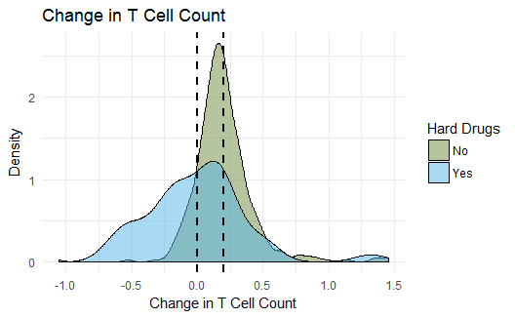

Above we see the distribution of T-Cell change for each group. The average hard drugs user had a T-Cell change of 0.0004 while the average non-user saw an improvement of 0.199. This difference is statistically significant.

#### Physical Health

Hard drug use had a negative effect on physical health scores. While the change in score for the average patient was estimated to improve by about 17 points, hard drug use decreased this estimate by 4 points. Additionally, older men were estimated to have slightly lower improvements, though this difference is less than 1 point. Higher physical QOL scores at baseline had a slight negative effect on the amount of change seen at two years. Again, the difference is less than 1 point, and makes sense, the better QOL score at baseline, the less far a man had to go to reach a ‘good’ QOL score.

Table 4: *Model estimates for change in Physical Health Score*

|  |  |  |  |  |  |  |  |
| --- | --- | --- | --- | --- | --- | --- | --- |
| Variable | Frequentist | | | Bayesian | | | |
|  | | ***Estimate*** | ***95% CI*** | | ***Estimate*** | ***95% HPDI*** |
| Intercept | | 17.83 | (10.63, 25.03) | | 16.702 | (10.1, 23.934) |
| Hard Drugs | | -3.552 | (-6.36, -0.74) | | -3.612 | (-6.387, -0.87) |
| Age | | -0.102 | (-0.19, -0.02) | | -0.104 | (-0.19, -0.021) |
| BMI | | 0.075 | (-0.1, 0.25) | | 0.062 | (-0.11, 0.232) |
| Adherence | | -2.086 | (-4.53, 0.36) | | -2.169 | (-4.557, 0.253) |
| Race (White) | | -0.359 | (-2.03, 1.31) | | -0.21 | (-1.867, 1.404) |
| Education | |  |  | |  |  |
| *College Degree* | | .184 | (-1.76, 2.13) | | -0.453 | (-2.328, 1.387) |
| *> College* | | -0.241 | (-2.14, 1.65) | | -0.067 | (-1.932, 1.849) |
| Smoker | | -1.426 | (-3.02, 0.17) | | 1.576 | (0.041, 3.133) |
| Baseline Physical | | -0.307 | (-0.39, -0.22) | | -0.306 | (-0.39, -0.222) |
| Error | |  |  | | 60.359 | (52.86, 68.66) |

*Figure 3: Average change in Physical Health Score*

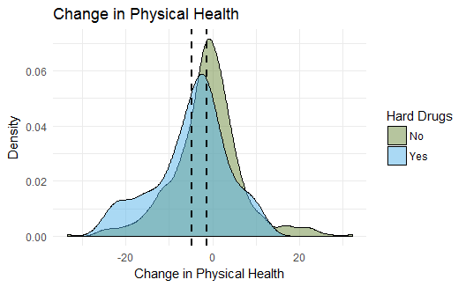

The average hard drug user had a change in physical health at year 2 of -4.80. Their non-user counterparts saw an average change of -1.337

### Discussion

Our results suggest that the hypothesis that hard drugs impair a person’s immune system, impacting improvement in health across laboratory and survey measures, is supported in the measure of T-Cells but not so in measure of viral load. Patients who used hard drugs were anticipated to have less improvement in T-Cell counts between immediately prior to and two years after initiation of a HAART regimen. This result is logical given the hypothesis that hard drugs negatively impact a user’s immune system.

Physical health, measured on a scale of 1-100 is indicated to be negatively impacted by hard drug use, decreasing by an average of 4 points from expected improvement of non-using individuals. This is not a surprising result as hard drugs are known to have many negative effects, including reduced physical health.

Partial F-tests suggest that no relevant information is gained in predicting change in viral load or mental health when we consider hard drugs in a predictive model which contains other demographic variables. Additionally, DIC model comparisons–a Bayesian framework method–agree that both models are not improved with hard drugs. All DIC values are shown in table 3 in the supplement.

Mental health was not shown to be impacted by hard drug use. Users were expected to show as much improvement in mental health as their non-using counterparts. These results are supported both in the Frequentist and Bayesian frameworks (Table 2 in supplement). Decreases in viral load did not differ significantly between hard drug users and non-users (Table 1 in supplement). This may be due to viral load being more directly impacted by HAART medication and less by the capability of the immune system.

Supplement

*Table 1: Viral Load model results. Values shown in log scale*

|  |  |  |  |  |  |  |  |
| --- | --- | --- | --- | --- | --- | --- | --- |
| Variable | Frequentist | | | Bayesian | | | |
|  | | ***Estimate*** | ***95% CI*** | | ***Estimate*** | ***95% HPDI*** |
| Intercept | | -0.248 | (-1.27, 0.77) | | -0.248 | (-1.293, 0.74) |
| Hard Drugs | | 0.071 | (-0.33, 0.47) | | 0.07 | (-0.325, 0.461) |
| Age | | 0.005 | (-0.01, 0.02) | | 0.005 | (-0.007, 0.017) |
| BMI | | 0.021 | (0, 0.04) | | 0.02 | (-0.003, 0.045) |
| Adherence | | -0.466 | (-0.81, -0.12) | | -0.466 | (-0.81, -0.123) |
| Race (Other) | | -0.185 | (-0.42, 0.05) | | -0.185 | (-0.416, 0.05) |
| Education | |  |  | |  |  |
| *College Degree* | | 0.292 | (0.03, 0.56) | | 0.292 | (0.018, 0.552) |
| *> College* | | -0.066 | (-0.34, 0.21) | | -0.066 | (-0.332, 0.212) |
| Smoker | | -0.032 | (-0.25, 0.19) | | -0.032 | (-0.26, 0.186) |
| Baseline  log(Viral load) | | 0.508 | (0.4, 0.62) | | 0.508 | (0.395, 0.619) |
| Error | |  |  | | 1.255 | (1.092, 1.415) |

*Table 2: Mental Health Model Results*

|  |  |  |  |  |  |  |  |
| --- | --- | --- | --- | --- | --- | --- | --- |
| Variable | Frequentist | | | Bayesian | | | |
|  | | ***Estimate*** | ***95% CI*** | | ***Estimate*** | ***95% HPDI*** |
| Intercept | | 17.83 | (10.63, 25.03) | | 22.105 | (15.07, 29.15) |
| Hard Drugs | | -3.552 | (-6.36, -0.74) | | -.758 | (-4.324, 2.687) |
| Age | | -0.102 | (-0.19, -0.02) | | 0.079 | (-0.027, 0.186) |
| BMI | | 0.075 | (-0.1, 0.25) | | 0.022 | (-0.194, 0.232) |
| Adherence | | -2.086 | (-4.53, 0.36) | | -2.347 | (-5.404, 0.696) |
| Race (White) | | -0.359 | (-2.03, 1.31) | | 0.043 | (-2.013, 2.113) |
| Education | |  |  | |  |  |
| *College Degree* | | .184 | (-1.76, 2.13) | | 1.761 | (-0.494, 4.191) |
| *> College* | | -0.241 | (-2.14, 1.65) | | 3.437 | (0.959, 5.798) |
| Smoker | | -1.426 | (-3.02, 0.17) | | -1.562 | (-3.518, 0.461) |
| Baseline Physical | | -0.307 | (-0.39, -0.22) | | -.522 | (-0.59, -0.453) |
| Error | |  |  | | 97.085 | (84.67, 109.9) |

*Table 3: DIC Table from full (hard drugs) and reduced (lacking hard drugs) Bayesian Models*

|  |  |  |
| --- | --- | --- |
| Model | DIC (Full) | DIC (Reduced) |
| Log(Viral Load) | 1433 | 1431 |
| Log(T-Cell count) | -201 | -166 |
| Mental Health Score | 3223 | 3227 |
| Physical Health Score | 3442 | 3441 |

*Table 4: Demographic summary of men lost to follow-up*

|  |  |
| --- | --- |
|  | N = 209 |
|  | *N(%)* |
| Race |  |
| Non-White | 97(46) |
| White | 112(54) |
| Smoke |  |
| Non-smoker | 101(48) |
| Smoker | 108(52) |
| Hard Drugs |  |
| No | 182(92) |
| Yes | 27(13) |
| Education |  |
| < College | 143(68) |
| > College | 32(15) |
| 4 years/Degree | 34(16) |
|  | *Mean(SD)* |
| BMI | 25.15(5.101) |
|  | *Median(IQR)* |
| Age | 39(33-48) |

*Figure 1: Trace Plot and Density of T-Cell model (top) and Physical QOL model (bottom). $B_{1}$ space is shown. All other parameter plots can be accessed in the published code*

